Unit Two: Energy and Sustainability (ESS, C, P and B)

Nuclear Energy | I can recall a description of Bohr’s model of the atom.  Nucleus in the centre, made up of two types of particles: positively charged protons and neutral neutrons,  Electrons orbit the nucleus in fixed, defined orbitals  The electrons travelling in these energy shells do not radiate energy
I can recall what is meant by atomic number, atomic mass, protons, neutrons (Year 9)

Relative atomic mass:
Protons + neutrons averaged across all the ‘silver’ on the earth
- Approximately equivalent to to the weight??
the average number allowing for the relative abundances of different isotopes.

Atomic number: the number of protons in the nucleus

Isotopes :
Atoms with the same number of protons but different number of neutrons
- Differ in atomic mass
- Have the same chemical properties
- Some isotopes have unstable nuclei (radioactive) and go thru decay in order to become stable
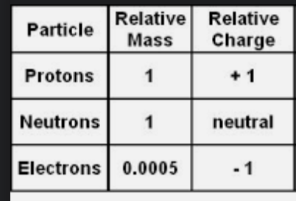
Proton
- Subatomic particle which has a charge of +1 and a mass of 1
- Number of protons determines an element
Neutron
- Subatomic particle which has a neutral charge and a mass of 1

Electron
- Subatomic particle with a charge of -1 and a mass of 1/1875
Nucleus
the positively charged central core of an atom, consisting of protons and neutrons and containing nearly all its mass.
Nucleon
a proton or neutron especially in the atomic nucleus
energy level : electrons orbit the nucleus in fixed defined orbitals, each orbital is associated with a definite amount of energy, hence they are called energy levels

I can definitions of nucleons, strong nuclear force, electromagnetic force, radioactive decay

Strong nuclear force:
The force between nucleons, protons and electrons holding then together
- If you have 2 protons next to each other, according to electromagnetic forces they should be pushing themselves apart, there should be repulsion but there isn’t, so there must be a stronger nuclear force holding them together
- If we have two protons that are far enough, electromagnetism will push them apart
- ‘the force that holds the components of the nucleus and the nucleus together’
- This is stronger than electromagnetic force when the particles are clse enough to rach other?? Double check tho

Electromagnetic force
- Attraction and repulsion, this happens between magnetic and electric forces

Atoms stay together by balance of nuclear forces and electrostatic force

Nucleons: The name given to the particles of the nucleus (protons and neutrons )

Radioactivity: naturally unstable nuclei and break apart emitting particles and/or energy

I can relate knowledge of strong nuclear force and (counters) electromagnetic force to the stability of nucleus. I can relate binding energy to stability of a nucleus and relate to nuclei becoming radioactive.

Strong nuclear force occurs in the nucley

I can describe the different types of radiation (alpha, beta and gamma) and explain the differences between them.

Radiation:
- Refers to particles or waves emitted by radioactive substances
- Nuclear radiation comes from nucleus
- In a radioactive atom, nucleus is unstable and so it emits particles or waves to form a more stable atom – this is radioactivity
- Background radiation occurs all the time and is invisible

Effects of radiation can?? Be seen so it can be detected using instruments such as Geiger muller tube

ALPHA RADIATION
- When an unstable nucleus goes through alpha radiation it emits a particle called alpha particle
- Same as helium nucleus – 2 protons 2 neutrons
- Parent nucleus – unstable isoptope or nucleus, which then becomes a daughter nuclei after each stage of decay
- Because ATOM’S NUCLEUS lost two protons, it’s going to become another element or isotope
- when an atoms nucleus decays and releases an alpha particle, it loses 2 protons + 2 neutrons
- the no of protons has changed so the decayed atom is a new element
- RECAP: atom decays into a new atom/(isotope?) and emits an alpha particle which is the same as an a helium nucleus with 2 protons and 2 neutrons
- Mass number decreases by 4, atomic number decreases by 2

BETA RADIATION
- Beta particle : high energy electron which is emitted by the nucleus of the decaying atom
- When an atoms nucleus decays and releases a beta particle, the neutron turns into a proton which stays in the nucleus and the high energy electron is emitted
- Mass number remains the same
- The decayed atom has gained a proton and so has changed into a new element
- Mass numbers remains the same, atomic number increased by 1

GAMMA RADIATION
- ‘excited’ parent isotope remains as the same elements
- Emits gamma radiation
- Daughter isotope is the same element
- RECAP: After an alpha or beta decay surplus energy is sometimes emitted – gamma radiation

 | Alpha (a) | Beta (b) | Gamma (backwards y)
Description of the change that occurs | Loss of Helium  | Loss of Electron  | High frequency electromagnetic radiation  High frequency short wavelength  
Charge | + 2 | -1 | 0
Relative atomic Mass | 4 | 1/1860 | 0
Velocity in air  Range in air?? | Travels a few metres in air | Can only be stopped by thick lead or concrete | Travels a few cms in air
Energy

Ionising power  the effect on other particles it may come across | Strongly ionising | Weakly ionising | Very weakly ionising
Deflection in electric field | Weakly deflected | Strongly deflected | Not deflected
Deflection in magnetic field | Weakly deflected | Strongly deflected | Not deflected
Penetration in air/penetrating power | Stopped by paper or a few centimetres of air | Stopped by a few millimetres of aluminium | Stopped by several cms of lead or several metres of concrete
Materials that stop radiation | paper | Aluminium | Lead or concrete
Path through matter
Risks to human body |  |  | Penetrate thru skin, organelles, causing mutations in dna

Not in objectives ??:
uses of radiation:
smoke alarms - alpha radiation
- alpha particles ionise the air
- if theres smoke present, it interacts w ions produced by the alpha particles and ionisation is reduced
- this means less current is flowing thru the air
leak detection in pipes - beta radiation
- radioactive isotope injected into pipe
- pipe is checked form geiger muller detecter to find areas of high radioactivity which r the points where pipe is leaking
how are radioactive sources sued safetly
- dangerous to handle
- people n clothing could be contaminated
safety precautions
- short exposure time as shot so possible
- monitor exposure with a film dose badge
- label radioactive sources clearly

 | I can identify specific materials that stop the different types of radiation.
I can write and balance nuclear reactions for radioactive decay

REVIEW WORKSHEET MAKE PAPER NOTES AND ADD

I can state what a half-life is and explain that different isotopes have different levels of stability.

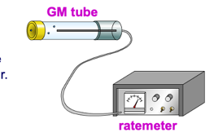
The time it takes for half the nuclei in a radioactive sample to decay
- Exponential graph
- Different nuclei, different half lives
- Decay spontaneous process that cant be controlled and is unaffected by conditions such as temperatyre and pressure

Radioactivity can’t be seen, no sound, no smell
- Detected through a Geiger counter; this is a Geiger-müller tube connected to a ratemeter
- This also measures amount of radiation
- Rate meter gives a reading of activity in ‘counts per second’ and a loud speaker clicks for each particle, or burst of radiation detected by the GM tube

RECAP GEIGER COUNTER
- Detects radioactivity and calculates the amount of radiation, gives a reading of activity in counts per second, or burst of radiation detected by the GM tube

 | I can interpret half-life graphs that measure mass, number of nuclei, percentage and activity (counts per sec/becquerels)
 | I can draw decay graphs given data and use the graph to calculate half-life.
I can describe what fission and fusion are and explain the differences between them

FISSION
- Splitting a heavier nucleus into smaller nuclei
- Often initiated by neutron capture : neutron bombarding nucleus, causing nucleus to ne unstable and therefore has to go through fission
- Releases large amount of energy
- Involves the release of gamma and free neutrons
- Not a natural eevent
- Fissile material : material capable of going through fission

DEFINITION : A neutron travelling at an optimum velocity and the correct angle enters the nucleus of the fissile material and causes the nucleus to become unstable. This instability causes it to split into two smaller fragments and an average of two or three neutrons are released along with a relatively large quantity of energy.

Using fissiom
- Atomic Bomb (fission bomb) – Triggering a chain reaction in U-235 or Pu-239
  - Must have a minimum amount of radioactive isotope to sustain a chain reaction (critical mass).
- Nuclear Power Plants – Convert heat energy from fission chain reaction into electricity.
  - Control chain reaction with control rods that absorb neutrons emitted after fission reaction.

FUSION
- Joining two lighter nuclei to form one heavier nucleus
- Releases a massive amount of energy
- Usually releases nucleons (neutrons and protons), as wel as nucleus
- Requires a lot of energy to take place
- The sun is powered by nuclear fusion, eventually it will run out of oxygen
Using fusion
- Fusion takes place in main sequence stars, and is what powers them.
- Needs extremely high temperature and pressure to get fusion to take place – need to overcome electrostatic repulsion between nuclei.
- We are researching how to generate and sustain a fusion reactor!

 | I can predict energy changes as a result of fission and fusion reactions.
 | I can write and balance nuclear reactions for fission and fusion reactions
I can state what is meant by mass defect in a fission/fusion reaction and how it relates to the energy released in the reaction

MASS DEFECT
- The total mass of a stable nucleus is always less than the masses of constituent protons and neutrons
- This difference in mass is called mass defect
- If you have oxygen nucleus the mass is less than if you split up all the protons and neutrons and add them up
- Where has the mass gone? -> its been converted into energy
- Mass defect = mass of nucleons – mass of nucleus

I can describe the relationship between mass and energy using E = mc2.

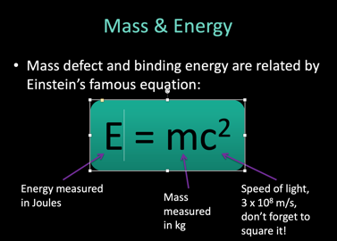

I can describe mass defect and binding energy and their relationship.

BINDING ENERGY
- The difference in mass is considered to be the binding energy of the nucleus
- The amount of energy that must be into the nucleus to break it apart into its individual nucleons
- To be stable its mass must be lesser than of its constituents
- If the mass of ⁴He was equal to 2 neutrons + 2 protons, the nucleus could fall apart

Binding energy/ nucleon
- Nuclei with a large binding energy per nucleon are the most stabke
- Smaller nuclei wil undergo fusion to become more stable
- Larger nuclei will undergo fission to become more stable
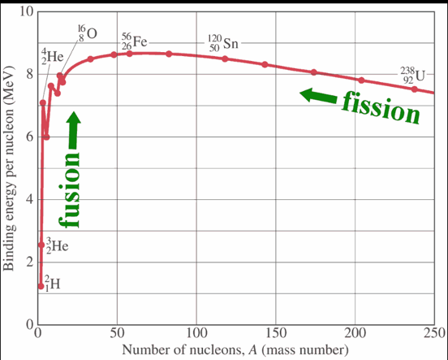
I can describe the main components of nuclear power stations. In particular, reactor vessel (encases and prevents radiation from escaping), the control rods (function in controlling nuclear reactions), fuel rods, steam generator (heat exchanger + turbine + generator), moderator (slows neutrons eg graphite or heavy water).

Reactor vessel –‘

 | I can explain, in simple terms, how nuclear power stations work to generate electricity. A nuclear reactor is a device in which nuclear reactions are generated, and the chain reaction is controlled to release large amount of steady heat, thereby producing energy.
I can describe an uncontrolled reaction in terms of neutrons escaping too quickly to maintain a chain reaction, resulting in the rapid release of nuclear energy, causing an explosion. Contrast this with a controlled reaction.

Why must chain reactions be controlled
- Chain reactions can generate a lot of heat : Chernobyl

I can analyse some advantages and disadvantages of using nuclear energy to generate electricity.

PROS | CONS
Small land footprint in comparison to the burning of fossil fuels | High risks if malfunctions
Reliable energy source | Nuclear waste produced
Carbon free electricity

EXAM | Covers all content before this point.
The Carbon Cycle | I can define biogeochemical cycle as a concept describing how chemical elements (e.g., nitrogen, carbon) or molecules (e.g. water) are transformed and stored by both biological and geological components in the Earth’s biosphere.
 | I can state the main forms of carbon in carbon cycle.
 | I can describe the main processes in the carbon cycle (respiration, photosynthesis, weathering, erosion, dissolving, deposition, fossilisation, extraction, volcanic eruptions, carbon fixation into carbon sinks).
 | I can explain how solar energy is transformed into chemical potential energy through the process of photosynthesis.
 | I can explain how the structure of plants is adapted to the process of photosynthesis.
 | I can explain how the structure of leaves are adapted to the process of photosynthesis.
 | I can state the word and chemical equation for photosynthesis.
 | I can state what respiration is.
 | I can compare and contrast the similarities and differences between aerobic respiration and photosynthesis.
 | I can organise the carbon cycle into a poster (electronic or paper). Emphasise the biological, chemical, geological or all three components of the carbon cycle.

